# **Project Plan Document**

**Instructions:**

1: Prepare a detailed plan for your project which comprises the below mentioned details.

2: Upload the pdf of the document through the given link.

3: The name of the document should be your Project ID.

**Things to be included as part of the project plan.**

1: Identify the lifecycle to be followed for the execution of your project and justify why you have chosen the model.

The lifecycle being followed is Agile methodology for execution of the project. We chose this because in Agile,

* Teams can quickly adapt to changes in requirements without negatively impacting releasing dates.
* It helps the technical department deliver high quality products with higher customer satisfaction.
* It follows a process which helps the team provide a deliverable product at the end of each sprint.

2: Identify the tools which you want to use throughout the lifecycle like planning tool, design tool, version control, development tool, bug tracking, testing tool.

* Throughout the development, we will be using a single multi-purpose tool known as Jira for version control, planning, design, and bug tracking.
* Jira is a multipurpose tool that is key to maintaining the proper order and lifecycle of a software development project.

3: Determine all the deliverables and categorize them as reuse/build components and justify the same.

* Software UI - reuse
* User Login - reuse
* Algorithm creation - build
* Database control - build
* Profile stats - build
* Components Integration - build

4: Create a WBS for the entire functionalities in detail.

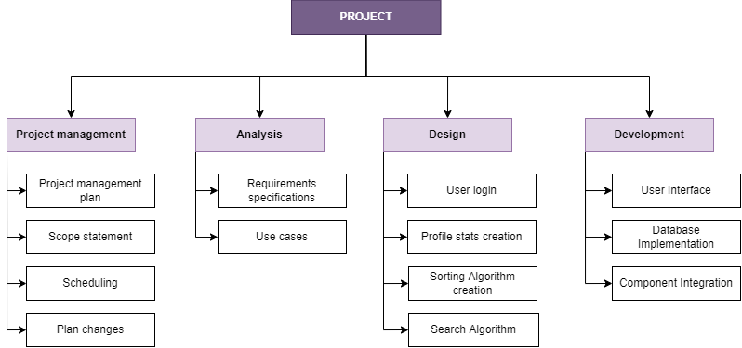

5: Do a rough estimate of effort required to accomplish each task in terms of months.

Effort = a(KLOC)^b

KLOC = 1.6

For semi-detached model, a = 3.0 and b = 1.12

Therefore, effort = 5.0785 (person months)

6: Create the Gantt Chart for scheduling using any tool.

